PORTSMOUTH & DISTRICT BEEKEEPERS ASSOCIATION
Minutes of the Committee Meeting held at Lakeside on Thursday 19th Oct. 2023 at 7.30 pm

Attendees: Mick Cotton (Chair) Donia Hodgson (Treasurer)
Wendy Gilbert (Secretary) Martha Dombey (Show Co-Secretary)
Glenys Jones (Show Co-Secretary) Sally Northeast (Social Secretary)
Mark Page (Bee Health Advisor)
1.Apologies
Sara Fitzgerald (Membership Secretary)
Non-attendee: Andrea Smith (Swarm Liaison)- continued ill health

2. Minutes of the last meeting Proposed by GJ and seconded by SN

3. Matters Arising
- A point was raised regarding the figures in the Treasury report which was a typing error
4. Charles Woood- talk on CB Dennis trust- apologies sent and postponed until next meeting
5. Treasurer’s Report

Opening Balance. £15,723.18
Income £11,772.87
Expenditure - (£15,199.42)
Closing Balance. £12,296.63
Shop account £773.51
Show | Profit
Stanstead | £118.10 | 3 Day Event
Portchester | £125.90
Rowlands Castle | £9.85
Hayling Island | £6.20
Collingwood | £39.50
Denmead | £46.25

6 Show Secretary’s Report
- On Saturday 25th November 10am-3pm a "Charity Christmas Craft Fair" and is being held in the Rowlands Castle Parish Hall. There will be 3 beekeepers selling honey and wax products and one helper only due to the limited size of the table provided by the fair (4ft) 10% of the proceeds to go to PDBKA.
- Martha Dombey will be stepping down from the position of Show Secretary but she will continue to answer website enquiries.
- The offer of a stand at the 2024 Collingwood Show was discussed and after last year's success it was agreed to accept the offer. GJ to respond to the relevant personnel.
7. Marketing report
- Mark Dombey (Webmaster) is waiting for a training link to Eventbrite to add to the website. Also, he is still waiting for the education beekeepers to send him the wording required to put with the link.

8. Charities Commission
- A few people have put their name forward for the nominations as members must be re-appointed. At the October Speaker’s meeting GJ will discuss details and answer any queries in preparation for the EGM on Tuesday 28th November. There will be the opportunity at the Speaker’s meeting for members who are not confident in technology to put their names forward on paper and be nominated and seconded for any roles they feel they could co-ordinate.
- It was noted that there are a few members who are not receiving update e-mails. If you know of anyone please contact SF -the membership secretary on membership@portsmouthbeekeepers.co.uk

Action: WG to send e-mail to members to inform them of the opportunity to ask any questions about the EGM and encourage them to apply for roles.

Action: WG to e-mail members that if they are aware of any members who are not receiving e-mails, to contact SF asap.
Action: SF to check Er2 for e-mails which ‘bounce’

9. Future Survey actions :
Discussion took place regarding the Survey which was taken last year. Ideas were given by the membership to take place on some of the face-to-face Speaker’s meetings
- Ideas were given to have talks/sessions run by the membership on some of the face-to-face Speaker’s meetings. It was agreed to schedule a member(s)-led evening each quarter. Members to be asked to let the committee know if they would be willing to give a talk/demonstration. It is also hoped that one of these meetings could be a panel of experienced members, so as to provide a opportunity for members to discuss a particular bee issue, gain advice and hear different perspectives/experiences.
- One of the other suggestions to be taken on board was to introduce a Table Top Sale at meetings, where any member will have the opportunity to bring along any beekeeping item, surplus to their requirements, with a clearly marked price and owner’s name. Any member would be able to purchase an item from the table with the money going straight to the seller. We plan to start this at the November EGM meeting.
- It was noted members had responded they would prefer the business aspects of last meeting of the year to be condensed and a more social meeting occur. Therefore, as the prior nominations and voting/appointing processes in the new constitution facilitate a shorter meeting, after the EGM there will be time for socialising with mulled wine, festive nibbles and tea/coffee with no cost to attendees. It is hoped that there will also be time to have a short Xmas Fun Quiz. There will be a festive raffle, plus a (free) members draw.
- Fondant will also be on sale at the EGM - £1 per slab.

10. Zoom meetings and the way forward
Discussion took place on the success or otherwise of the September Speaker’s hybrid Zoom meeting
- GJ, who led the meeting, stated that the equipment worked well and the quality of the sound was good. MC was in Scotland yet he opened the meeting from there and many followed the meeting from home. It was deemed a success so there will be more in the future,
- The January meeting, prone to possible wintery weather, will be a full Zoom meeting.

AOB

- PAT testing is about to be booked, All electrical equipment is to be collected from the Marriot by MC and placed in the Skep. DH is awaiting Cliff’s return
- SC has 6 jackets but to improve safety for training sessions, trousers are needed. Action:AS to search for suitable protective trousers
- Fort Cumberland Apiary Manager has raised concerns about a small number of broken, unused, old hives. It was agreed that these hives be destroyed and the site cleaned and restored to good condition
Action. WG to contact Julia Porter who will liaise with Linda Smith to clear and tidy the site
- The Omlet hive , presently situated at the Sustainability Centre, is not used and becoming in the way, It was proposed to offer the hive to a PDBKA members if the owner could not be traced. There will be closed bids made to DH. This would be shown on Members Facebook page
The Minutes (see below)
The EGM

The meeting closed at 9.05 pm.

Next meeting to be held on Thursday 9th Nov 2023 at the Lakeside starting at 7.30pm

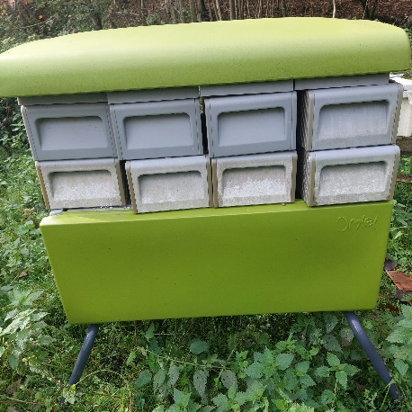
The Omlett Beehaus hive
The owner has been traced and donated the hive to PDBKA.

If you would like to make a closed bid on this hive please send your bid to Donia Hodgson on Treasury@portsmouthbeekeepers.co.uk or provide this on paper to Donia at the EGM. Bids must be submitted before 8pm on Tuesday 28th November 2023.

